PLACEMENT OF THE 1991 MODERN HEADSTONE ON THE GRAVE OF ANNA JOHANSEN DAHLE

Complied by Larry D. Christiansen from oral and written accounts of Nancy C. Bott

An enlightening incident took place at this grave site on the first day of the Sesquicentennial Dahle Family Reunion on September 14, 2012, that promoted the following article. What I know comes from one of the participants of a verbal dispute at the grave site and by two other relatives who witnessed the event. A day after the occurrence, I in North Carolina received a telephone call from my niece Nancy Bott from Brigham City, Utah. She related how she and three or four cousins and friends joined a group from a nearby facility where reunion activities were being held and were taken to the Logan City Cemetery and joined others around a nice and informative headstone on Anna Johansen Dahle’s grave. As Nancy approached the headstone, she hoped that she might have the opportunity to express thanks to any who had contributed money for the modern day headstone, only to be averted by a man seemingly seeking to take all the credit for the accomplishment. The leader, Eric Dahle, addressed the gathering around the headstone telling some about the lady buried there and concluded with telling how he had had the monument made and placed on the grave. Nancy, a third great granddaughter of Anna, was more than astounded, and when an opportunity came she confronted Mr. Dahle asking him directly if he had placed the headstone in its present position. After receiving an affirmative response she asserted that she had been the one to do this work and cited the Brigham City monument company by the Bott name along with telling the man that according to his written words he hadn’t or couldn’t locate this ancestor’s grave. As an adjunct to Nancy’s telephone account in mid-September and after some prodding by this writer, Nancy wrote the following in a message: “Then, at the reunion this summer, he walked us over there and told how he had it made and I stood there with my mouth open. After his little speech I said to him. ‘You think you put this here?’ He said, ‘I think so.’ I said, ‘Oh no, you couldn’t find it remember. I found it and my father-in-law put this here.’ He then said [‘]well I do remember someone with a Bott name had something to do with it.[’] That was all I wanted to say to him.”
I don’t know how many in the group understood what had just taken place in Eric’s initial claim and the exchange between him and Nancy in which two different persons were claiming to have had the headstone made,
inscribed, paid for and positioned on the grave. It wasn’t a mere misunderstanding of the initial claim of Eric saying he did it, for Nancy had asked a direct question to him while pointing to the headstone, querying for his confirmation of his earlier claim. Eric soft-pedaled with “I think so,” and mentioned the name Bott as possibly being involved. When confronted with a direct challenge to his claim, Eric vaguely skirted the issue without acknowledging he was wrong or providing details on precisely what he did to bring about the headstone in question.
Nancy did not press her challenge by asking difficult questions of Eric, like what monument company he used, when and how he located the grave that he had in his book stated it couldn’t be located, etc. For all the information that the Dahle reunion disclosed or unveiled in their two days of meeting, they surely missed a golden opportunity to reveal the true story of Anna’s headstone that only came up briefly, inadvertently at the grave site. There may be some who don’t care about it and possibly others who wish the reunion incident at the grave site would never to be mentioned again. However, I care and remain more than shocked at what I had been told by a nephew and nieces at the grave gathering. So now in a more-in-sadness-than-in-anger critique I will try and set the story of the present headstone on Anna Johansen Dahle’s grave as straight as I can.
First off, Nancy Bott is the daughter of my brother Max Christiansen of Newton, Utah, whose Dahle lineage is traced through her father Max to his mother Ethel Dahle Christiansen (Nancy’s grandmother) to Hans Dahle (Nancy’s great grandfather) to Johannes and Martha Dahle (Nancy’s 2nd great grandparents) to Anna Johansen Dahle (Nancy’s third great grandmother). Over the years Nancy has engaged in extensive genealogical research on her ancestors, including the Dahle line. The research had taken in Annie Johansen and where her christening record and other details were discovered long before she became involved in placing a monument at her grave. Early in 1991 she was living in an LDS ward wherein there was a descendant of a lady who married a Dahle in Clarkston, and ensuing discussions took in the Dahle family. This produced a concern about the matriarch of the Dahles in Utah, her 3rd great grandmother Annie. According to Nancy’s written words, “I had been reading that Dahle book which is primarily about the second wife and that family. When I read in the book about her being lost in the Logan Cemetery I decided to check it out myself. I went to the sexton house one afternoon with my information. I asked if she was there and he gave me a map showing me where she was. She is right next to her son John. I was soooo excited to find the actual spot.” The sexton of the Logan City Cemetery stated the grave had not ever been lost and it had not been moved; the grave was where the body had been interred in 1864. The sexton took Nancy to the grave location, and “there was no head stone there.” Only the cemetery records showed the location of the grave, but Nancy was not content in just locating the grave site, she began immediately to think about putting a marker there. In her personal journal she wrote: “I need to get this done now.” She began inquiring on headstones at her father-in-law’s monument business in Brigham City to see some headstones, learned cost and some sage wisdom—“that a head stone is for the living and not the dead.” Along with Nancy deciding what she wanted inscribed on the stone, she was advised on the placement of the inscriptions. In Nancy’s recollection she wrote: “I figured out what I wanted to put on it, looked at her original birth record from her parish to get the correct spelling and the date. Then I read the records to see when she came to Utah and who her children were.” In the inscription it was found there was room to record that Anna was a Utah Pioneer, her birth and death dates along with Anna’s children’s names on the back of the monument. The extra inscription would increase the expense but the main idea was to do it right.
Nancy knew she couldn’t afford to pay for it all herself so she made a list of her known immediate family and then looked into the telephone book for Logan, seeking more Dahles. Then she wrote a form letter explaining what she was attempting to do and asked those contacted to contribute if they could afford to do so, stating she thought five dollars would do it. In her form letter she noted that due to postage cost, she could not respond back with individual thank you for contributions, so she included a thank you in advance. Nancy mailed her letters and could only wait and wonder about likely responses. She didn’t have to wait long as responses came back, and she much later wrote, “It was funny how soon the money started coming from family members.” With their contribution there were notes expressing things like surprise that there wasn’t a marker on the grave, or saying thanks and “good job.” A couple included a note saying how nice it was that Nancy was doing this and saying thanks a lot and here is the five dollars but no money was in their letters; as they had the best of intentions but just forgot to enclose the money. Then there was Dahle Toyota who sent in $100, and they received one of the few thank you notes along with $95 returned. In response to a specific request Nancy concluded her account writing: “My father-in-law, Max Bott was busy getting the stone ready while I was getting the money. I finally had it and one day he and his helper took it to Logan, Max knew the sexton and they had a visit and they just put in the cement and the headstone on top of that. I felt really good about it. . . . I am so grateful to our family for pulling together and getting the money so this could be accomplished.”
Back to the beginning of this article and incident at the grave site in September of 2012, wherein after her injecting doubt on the bold claim of the man, she wrote this short paragraph: “The people standing around all commented on what a nice headstone it was and they liked the fact that it had so much information on it. I didn’t
know any of the people and I think they were mostly from the other wife. The relatives I had there with me, Rodney and Karole, JoAnn, Karen and husbands knew the real story because they helped put it there.”
Anne Johansen Dahle died in Logan on November 15, 1864, after a short stay in Utah (reached in September of 1862) and residing in Logan from October of 1862. Her time in Cache Valley was two years and one month. Her emigration from Norway to Copenhagen, Denmark to Hamburg, Germany to cross the Atlantic Ocean to New York City was only the first phase of her journey. By railroad and steamboats she traveled to Florence, Nebraska to continue her journey hundreds of miles across the Great Plains by ox team to Utah. Shortly she along with a son and his wife moved about ninety miles northward to Logan, a new settlement only in its third years of existence. We wished we know more about this wonderful mother in her native land and during her short stay in Utah. In the Logan Cemetery, approximately one hundred and twenty-seven years after her death a new modern headstone was placed on her grave in 1991. Her American family kept the memory of this ancestor alive sufficiently until a third great granddaughter, Nancy C. Bott, seized the opportunity to do more. All thanks to Nancy’s efforts of finding the grave, wanting a headstone, checking with a monument company for a headstone, deciding on the inscriptions to be placed there, soliciting for contributions, collecting the money, paying for the headstone and being present when the headstone was put into position. Per Nancy Bott’s deeply engrained disposition, she would minimize her efforts and turn aside any vainglory to give thanks and appreciation to all who contributed to the headstone—and making it a family project and achievement—giving many more descendants an opportunity to participated in this venture.
Hopefully I have been able to tell some of the story of how the 1991 headstone on Anna Johansen Dahle’s grave came to be, but Nancy could have explained it better with more depth. Instead she kept insisting it was “no big deal.” Well, Nancy on this you were wrong as you went more than the extra mile, and it was a tremendous accomplishment done with little distress except for your tireless personal efforts. Without a doubt it was an endeavor that needed to be done, and was accomplished in a grand style with the focus on the beloved ancestor with no thought of grandiosity for doing it.

Three photographs of the modern headstone follow along with a postscript.
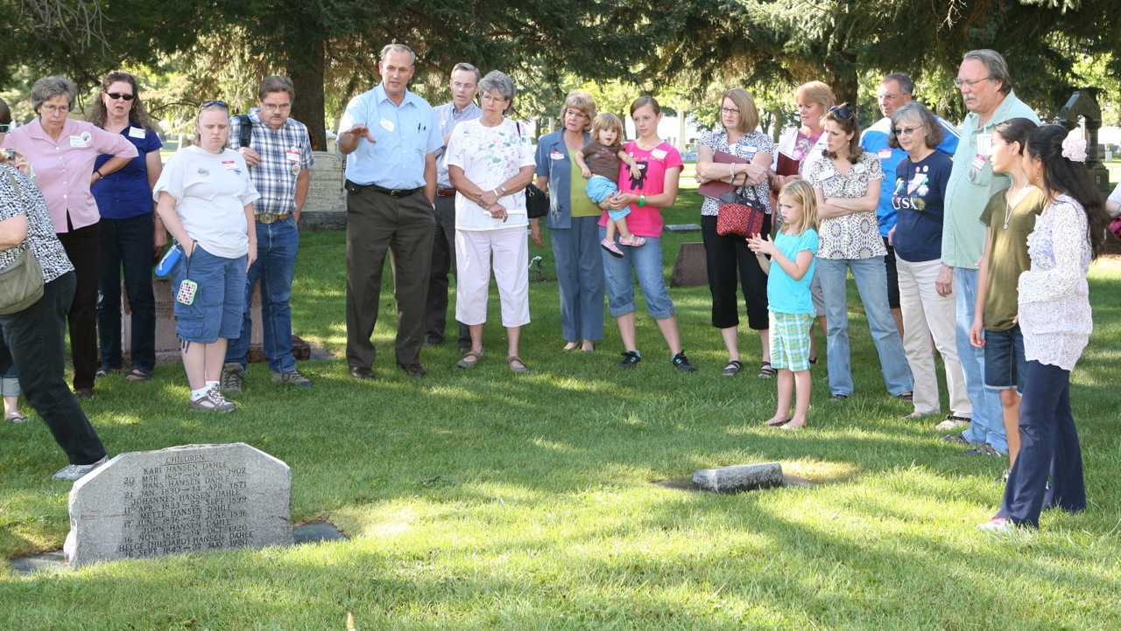
The grave and headstone of Anna Johansen Dahle in the Logan City Cemetery Sept. 14, 2012.

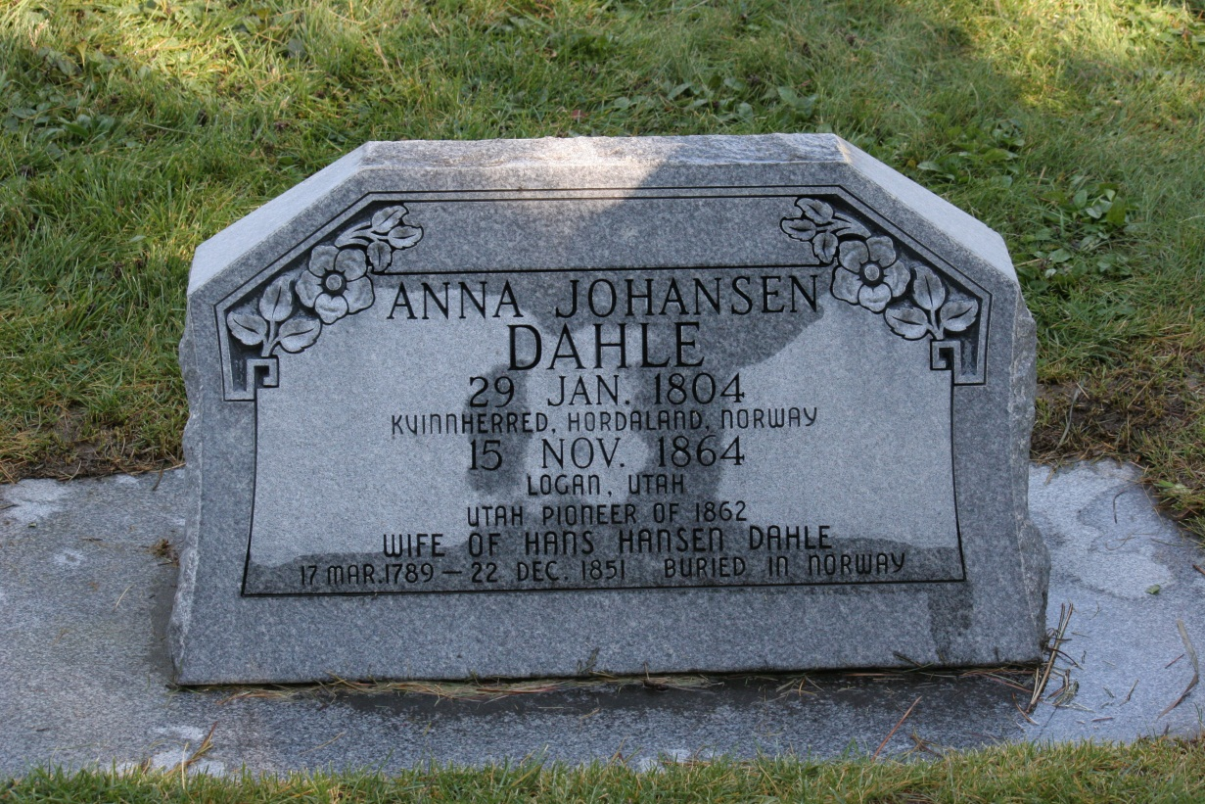
Front of Anna Johansen Dahle’s headstone.

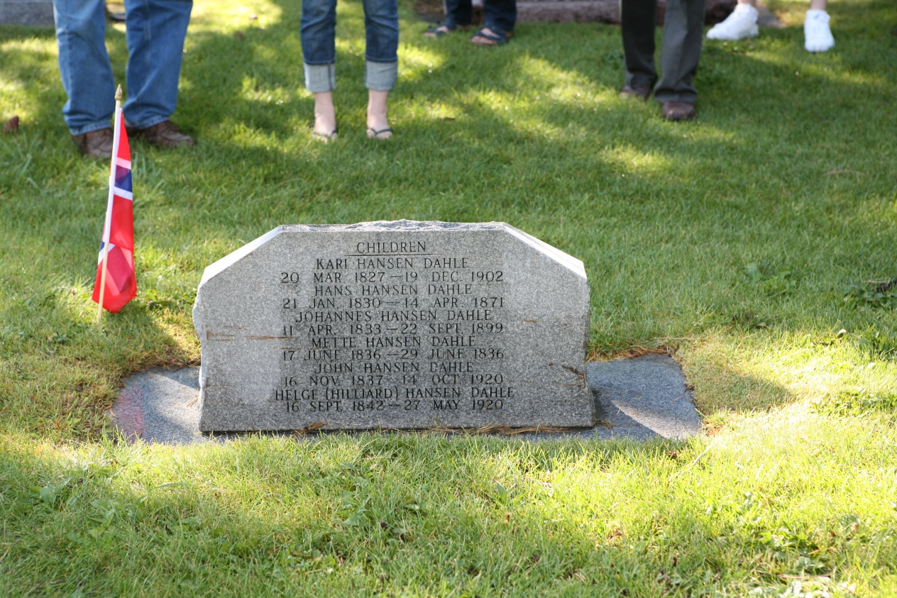
The backside of the headstone showing the children of Anna Johansen Dahle.

Postscript: After reading the above if you would like to add a short note of appreciation for Nancy’s efforts or a
rebuttal to the above article along with your name, they will be posted for others to view.
Send items to Larry Christensen (lcandbc60@bellsouth.net)

