SKETCH OF THE LIFE OF ANNA JOHANSEN DAHLE
By Larry D. Christiansen
Preface and Introduction:
A brief glimpse of the history of the Norway may be of some value as background. The inhabitants of the Scandinavian
Peninsula found the easiest way to travel and communicate was via the sea. In the 8th century the people began to build ships of
a larger size and sent them on expeditions to initiate the Viking Age. The North Sea rovers were traders, explorers, colonizers
and plunders. The earliest non-Viking source to record such a raid came in 787 A.D. and by 793 the Vikings hit the British Isles.
Norway was the main home of the venturesome Vikings whose raids tapered off following the adoption of Christianity in 994
A.D. The traditional date for the formation of the Kingdom of Norway came in 872 A.D. with the establishment of a hereditary
kingdom. Then came a period of expansion with settlements in Britain, Ireland, Faroe Islands, Iceland and Greenland, which was
prompted by a fear of over-population at the home land. Intermixed were civil wars and competition by way of commercial
and defensive confederations and the spread of the Black Death which weakened the country. In 1380 A.D. Norway was
absorbed into a union with Denmark that lasted more than four centuries and ended when the country sided with the losing side in
the Napoleonic Wars in 1814. Denmark was forced to cede Norway to Sweden under the Treaty of Kiel in 1814. The
Norwegian holdings of Greenland, Iceland and the Faroe Island became Danish. The end result was a short war with Sweden and
there developed a union of Sweden and Norway. The union persisted until 1905, when Sweden recognized Norwegian
independence. The story that follows comes about midway in the union of Sweden and Norway period whereby Norway had its
own constitution and controlled most aspects of the people lives, except foreign policy. The Viking language, Old Norse,
became the mother-tongue of present-day Nordic languages.
In regard to geography, Norway on the western’s side of the Scandinavian Peninsula has a rugged coastline, broken by vast
fjords and thousands of islands, stretches 16,000 miles, and its eastern and northern border is shared with Sweden, Finland and
Russia. Much of the country is dominated by mountainous (32% of the mainland is located above the tree line) or high steep
terrain, especially along the many fjords. The northernmost part has a mostly maritime subarctic climate and an Arctic tundra
climate. The landform consists of elevated plateaus, deep forested valleys and a few remaining glaciers (the largest in continental
Europe). The country’s elongated shape somewhat conceals its size for the contiguous area is slightly larger than the State of
New Mexico. The climate of Norway is much more temperate than expected for such high latitudes; this is mainly due to the
Gulf Stream (North Atlantic Current with its extension the Norwegian Current) raising the air temperature. Only about three per
cent of the land is considered arable thus agriculture was practiced in small amounts due to the land form and a short growing
season. All taken into consideration, it is not surprising that Norway is the second least populated country in Europe, and only
Iceland and Finland have less arable land than Norway. The best farming area was in the south central plateau slope into the
Trondelag, a hilly and mountainous region with strips of fertile land on the edges of Trondheim Fjord. But further to the south
were additional lands found along the southern coast and fjords. Hardanger Fjord area has been a fruit-growing region since the
14th century. In this latter region particular attention will be focused upon a coastal area in and near Bergen.
This area is now called by the name of Hordaland County but that name was not affixed to it until 1919. This specific area,
noted for more than a thousand years, was eventually known as Hordafylke since bout 900 A.D. In the early 16th century,
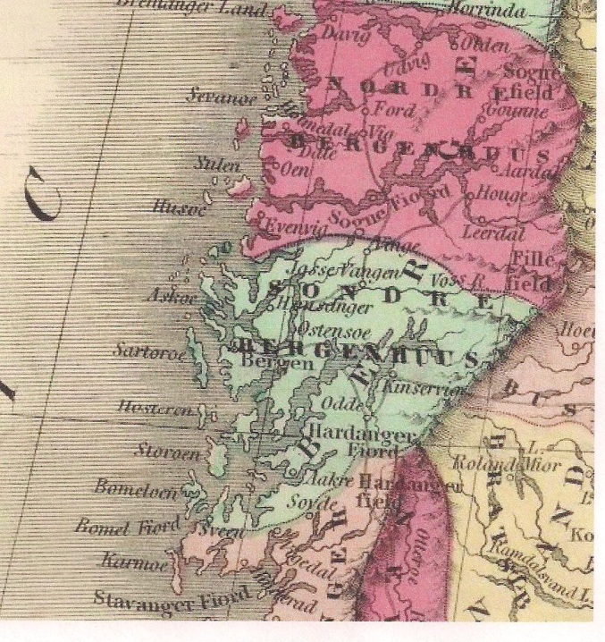
Norway was divided into four lens with one somewhat centered around Bergen and encompassed a sizeable area was the Bergenhus len. In 1662 A.D. the lens was replaced by amts (forerunner of county), and in 1763 the Bergenhus amt was divided into a northern and southern part: Nordre Bergenhus and Søndre Bergenhus amt. Maps of 1850 and 1860 of Norway show the division and those names remained in effect until 1919 when the area was renamed by reviving the old Norse name of Hordaland fylke for the much smaller administrative section. At the time the city of Bergen was classified as a city-county (byamt) from 1831 to 1972 when Bergan lost its county status and became part of Hordaland county. During the following story the correct geographic name for the area was Søndre Bergenhus amt as shown on the maps of that time period, but if modern maps are used, the location would be in Hordaland. Søndre Bergenhus was an area on the western coast near the southern portion of the country with its main appearance being its numerous islands, waterways and fjords that stretch far inland. It is split from southwest to northeast by the long, deep Hardangerfjorden the second longest fjord in Norway (third largest in the

Map 1 – Section of 1860 map of Norway

world) that extends from the rocky coastal islands to the frozen heights of the mountain’s icecaps and glaciers, a
distance of over 111 miles. The primary area of interest of this article will be along this fjord where fishermen
plied their trade and some small-scale farming was performed along some fertile areas. Villages, in the ordinary
sense of the word, were few and far between here as the main center of a community was the gard or farm which
existed within a municipality, an area or district rather than necessarily a town or village.

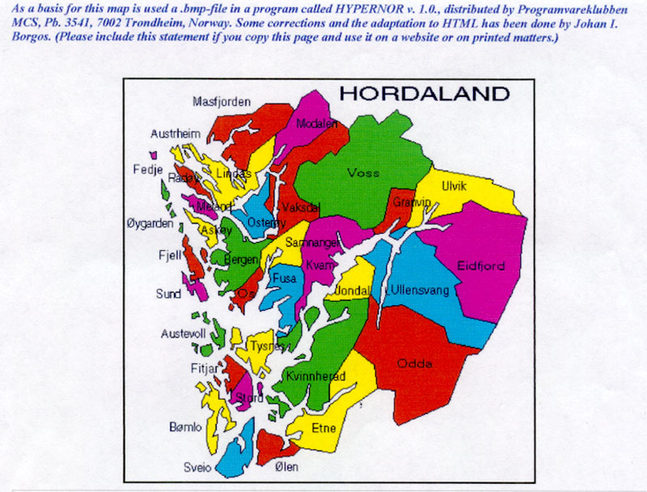
Map 2 - showing the present-day alignment of the 33
Municipalities of Hordaland County.
Of special interest is the Kvinnherad Municipality, shaded in green, that lies primarily to the east of the Hardangerfjord but note that the fjord divides a small section on the western shore of the fjord along with the large island of Varaldsøy and a small section to the south.
Hordaland County area total - - 15,440 km²
continental area - - - 13,367 km²
area of fresh water lakes - 886 km²
area of glaciers - - - - 338 km²
Agricultural area in use (2010) - 282 km²
A square kilometer (km²) = 0.361 sq. miles
or 247.1 acres
Note the small amount of land in use for agriculture in 2010.

Formannskapsdistrikt was the name for Norwegian local self-government districts put into force in 1838. This system
of municipality was created to fulfill an express requirement of the Constitution of Norway that required every parish to become such a district. Thus the Norwegian State Church (Lutheran) districts became a worldly administrative district as well as a religious jurisdiction . The introduction of self-government in rural districts was a major political change. The
farm culture (bondekultur) that emerged came to serve as a symbol of nationalistic resistance to the forced union with Sweden. The legislation of 1837 gave both the towns and the rural areas the same institutions which involved a minor change for the town, but a major advance for the rural communities. In 1838 a total of 396 formannskapsdistrikts were created. Among the twenty-six formed within Søndre Bergenhus amt were the following:
Os was established as a municipality 1 January 1838. Fusa was separated from Os in 1856.
Vikør was established as a municipality 1 January 1838, and renamed Kvam in 1912.
Tysnesey was established as a municipality 1 January 1838.
Kvinnherad parish was established as a municipality 1 January 1838. Later Fjelberg, most of Varaldsøy and parts of Skånevik, were merged with Kvinnherad in 1965.
NOTE: The municipality names have been spelled several ways. For example. before 1889, the name Kvinnherad was
written "Quindherred," then from 1889-1917 it was "Kvinnherred," and since 1918 it has been spelled "Kvinnherad."

Kvinnherad Kommune or municipality is located at the mouth of the Hardanger Fjord. The fjord actually bisects the municipality with the smaller part to the west (on the other side of the fjord) with the hamlets of Ølve and
Hatlestrand and the larger peninsula with the Folgefonna glacier to the east. The width of the Hardangerfjord at
this location ranges from three to seven miles. In the mid- nineteenth century the whole of Kvinnherad was rural.
Today near the southern tip is Husnes the largest village with some 2300 inhabitants and a commercial and
education center. Rosendal with 1000 people is the administrative center. The maps of the area illustrate how
the water ways and the sea are extremely important factors in this area of Norway. Travel in Norway before 1870
was mostly by boat, and if a boat wasn’t involved travel was most often by foot.
Ølve was located in a picturesque setting on the north shore of the Hardangerfjord, specifically on Husavågen
Cove with a magnificent view of the Folgefonna glacier, the fjord itself and the mountains of Kvinnherad. The
community had a long tradition in small scale farming, fishing and boat building. A sizeable inland lake, the
Kvtebergsvatnet, lay a short distance from the narrowest part of the cove. The shortest water route from Ølve to
Rosendal was from ten to twelve miles, which by land roads and commercial ferry was at least three time the
distance by water.
Map 3 - Below showing a view from a modern map of Hordaland County with enough size to see the geographic area with the great number of islands and waterways.
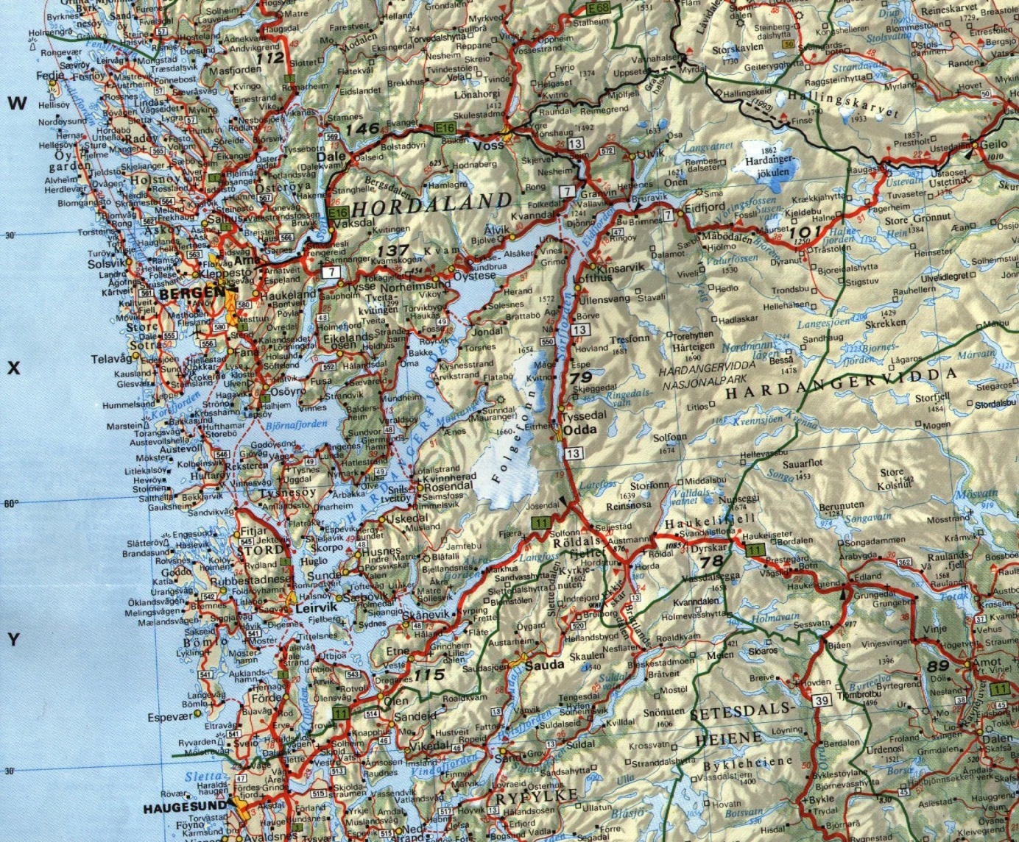
Map 4 – To the left -Sketch map of a portion of Hordaland County.

By a close scrutiny one can depict the dotted line of the various municipalities and in particular that of Kvinnherad showing it on both sides of the fjord. Bergan City is to the northwest
The area of special interest is the smaller portion on the west side of the fjord. Just to the west (left) of the letters “ng”in written name “Hardangerfjorden” lay the small
village of Ølve in Husavågen Cove which will serve as an orientation point for the following account.

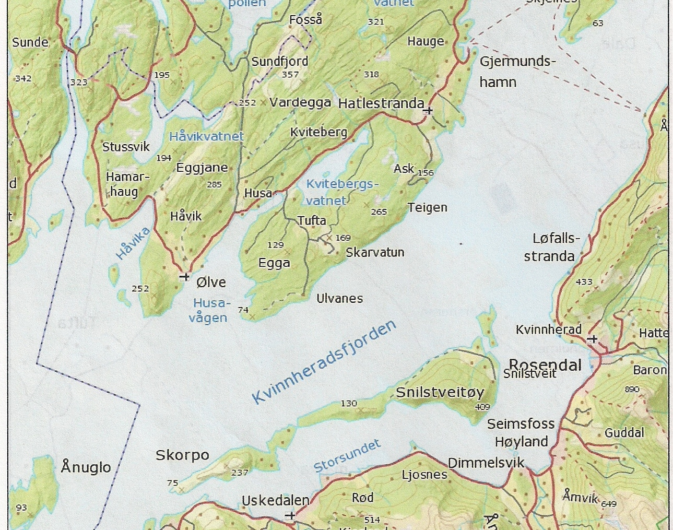
Map 5 – Focusing on the western portion of Kvinnherad Municipality where the roots of the Dahles originated.
The Dahle farm was just to the north of Ølve a short distance on the shown road and near the Husavågen
Cove. The Tveitane farm was further north possible beyond Husa but no more than ten miles.

Sketch of the Life of Anna Johansen:
A decade before Norway moved from a union with Denmark into another union with Sweden on January 29, 1804, a daughter was born to a family on their farm at Tveitane in Søndre Bergenhus amt (renamed Hordaland fylke or county in 1919). The new arrival was given the Christian name of Anna by which she was christened in a Lutheran parish a short time later. For centuries Norwegians were only given this Christian name (sometimes with a second given name) with no regard to an established surname or hereditary name. A custom formed whereby for better identification a second name was given that the person was in a patronymic form as the son or daughter of the named father. Initially the tie to the father was expressed by way of the father’s first name with a sen or datter attached, but in time for females the masculine form of the patronymic was preferred and in the 1870s the law ordered it. Thus, with Anna born in January of 1804 she was identified as Anna Johansen with the second name strictly for better identification via the patronymic form. Anna’s parents were Johans Steinsen and Mette Torkildsen, and the patronymic was used for their second name. The residents tended to think of themselves as the inhabitants of a particular valley or distinctive area rather than as Norwegians. We know little of Anna’s early life except that she was the oldest daughter in the family and had eleven or twelve siblings living on a rural farm called Tveitane farm, owned or operated by her parents. She was christened in the Lutheran Church and church attendance was within the nearest parish which was at Hatlestrand. The farm was on the north and west side of the Hardangerfjord some forty miles southeast of the large city of Bergen and within a short distance north of the small hamlet of Ølve and about seven miles across the fjord from Rosendal (see maps 3 and 4 above). Most likely she worked in the fields and had other chores on the farm, but because she was the oldest daughter, it could have been than she was primarily engaged in tending her younger brothers and sisters and taking care of the home while her mother was occupied with her babies.
We can only guess on her daily life and social customs; however, we know that most of the people participated in festive occasions where special clothing was worn and involved much singing. Such celebrations as Constitution Day (May 17th), Sukhansaten (Mid-summer Eve), Olsok or St. Olaf’s day on July 29th (honoring an early king) and Christmas were marked by the general public as well as by family feasting. In addition there were Lutheran Church celebrations, and perhaps smaller parties by close neighbors. These occasions brought the farming families together from the scattered rural farms with desired social contacts. Singing, eating and lots of visiting were enjoyed and in time closer social relationships were fostered. At this time marriage was regarded as essential with women married on average at the age of 25. Perhaps due to the somewhat isolated rural location it was not unusual for such unions to have much older spouses and involve close cousins.
In some way Anna came to know a man who owned a farm in the same vicinity of Søndre Bergenhus amt and was about fifteen years older than Anna. This man was Hans the son of Hans, so called Hans Hansen who as the eldest son had inherited the family farm from his father ten years earlier. There are indications this Hans had relationships with a woman or two prior to his known marriage in the summer of 1822 but produced no male heir. So on July 6, 1822, the eighteen-year-old Anna married the older man at her family’s farm. The new couple resided on Hans Hansen’s farm at Vestledale (or Lille-Dale) which was not far from where Anna had been born and reared, probably within ten miles. Personal research has failed to detail the specific type of farming done on the farms of Anna’s father or her husband. Thus, trying to ascertain a typical small farm in the location and time period involves combining what can be gleaned from Norwegian history and some calculated conjectures. It has been established that by 1865 three-quarters of Norway’s population were living on farms. Still, a large portion of these farmers supplemented their living by combining other economic activities such as fishing, forestry, or a trade such as blacksmiths, carpenter, shoemakers or other trades. In addition those farmers with easy access to grazing land and forests used in common by various local farms were very fortunate. Statistics gathered from throughout Norway in different localities show a trend toward stock raising in the latter half of the nineteenth century with by 1875 the average farm self-owned by a farmer had over six cows. If the farm of Hans Hansen (husband of Anna) fell into the same pattern, then the crops grown would have been oriented in sustaining their animals. Husband Hans had worked on the family farm from a youth and now had owned and operated it for a decade. It was a small holding which the modern day Dahle researchers have estimated that it covered about twenty acres, retaining its size due to the custom of the oldest son inheriting the farm from his father without divisions.
Most assuredly Anna had much experience in taking care of a home, and cooking and preparing food (often well in advance of being used) before her marriage, but now on her own with a new husband, besides helping on the farm she took care of the cooking, cleaning, washing, and almost anything else, in and for the couple’s home. There could have been a smooth transition with little change or a whole new world requiring much adjustment. For example, some Norwegian dishes may have not been favored by both her father and her new husband. Did one or the other like rakfiesh (trout or char salted and fermented for two or three months or longer and then eaten without further cooking), or did one or the other prefer lute fish (dried and salted and steeped in lye). If they raised sheep on one of the places where Anna lived, then Smalahove (sheep head or half a head with wool burned off and then boiled for several hours) could have been considered a favored traditional dish at one place and revolting at the other. There could have been new items such as pickled herring, smoked salmon or even gravlaks, a popular fish dish made by burying salt cured salmon in the sand for a period of time after which it was served raw). Meat came from farm animals, game and fowl. The Norwegian cuisine was produced in the days before refrigeration where it took some ingenuousness and skill to preserve food. Other choice foods were bread (lefse a traditional soft flatbread made out of potato, milk or cream and flour and cooked on a griddle), sour milk, cheeses and porridge. The latter known as “grot” was the main food and usually served with flat bread and sour milk. In the days before kitchen tables were common, a large bowlful of porridge would be prepared for the entire family and passed around with each person taking turns eating with their private spoon before passing the bowl to the next person. When each individual finished eating, they would lick their spoon clean and hang it up until the next time it was needed. With the advent of tables this process was refined somewhat.
A common generalization of Norwegians depict them as stoic, resourceful, honest, and self-sufficient to the point wherein one writer noted they needed to buy or trade for only three things—sugar, salt and glass. Other characteristics ascribed to them were their habit of being scrupulously clean in regard to their homes and meticulous in the care of their animals. Some have then added injudiciously that the Norwegians in the mid-19th century were not so concerned with their personal hygiene. Whatever the actual case, it is mindful to note that notwithstanding the bathing practices of the ancients with public and social bathing facilities, which later Christians condemned, and by the time of the Renaissance personal hygiene was neglected and in some cases discouraged. It wasn’t until the late 19th century that physical cleanliness with regular bathing was again regarded as important. Besides, in rural farm districts and homes there were no facilities such as public baths and saunas. Unless a person took advantage of the lakes and fjords to bath in cold water, and there months were when it was too cold for outside bathing, especially for women and children. To do the bathing at home required carrying much water which had to be heated by fire or have rocks heated to place in the water to warm it. It wasn’t convenient or easy to bath very often.
Even more difficult and involved was the washing of clothing, bed linen, towels, etc., which was not a one day affair for large families. Wash day had to be carefully planned out to make the best use of resources and available hands, and usually began the night before the wash day. It has been estimated it took from 150 to 200 pounds of firewood to heat the quantity of water required for doing the laundry by hand. A considerable amount of water had to be carried to the heating boiler for the washing and more for rinsing. Once the water was heated sufficiently the items needed to be washed were put into the heated water with home-made soap, then the laundry was hand washed by agitating it with a wooden paddle, with some soiled to the point of requiring some treatment with lye soap. After the washing came the rinsing with clean heated water followed by wring the excess water out of the laundered items and hung out to dry or dried inside the house during inclement weather. Since there were few times when the items to be washed could all be done at one time, the items to be washed were done in batches, with the process above repeated for each batch. Primitive farming with a hand plough or cutting grain or hay was hard work, but it was no more difficult than washing the laundry for a large family.
Picture 1: An 1966 aerial view of the Vetledale and Storedale areas in Hordaland County,
Norway. Containing the caption: “ Dalen kring 1966, Vetledale t.v., Storedale t.h., Roaldstveit t.v.
bakgrunnen” (barely visible at the bottom of the above picture).

On Picture 1 the there was an identifying line stating it covered the area of the Vetledale and Storedale farms which was about all cut off but shown in the title in italics. This aerial view shows the location of the Dahle family farm and the area surrounding it. The first farm house and associated buildings (just left of center) along the road is located on the Dahle farm. The farm from the 1850s according to the latest Dahle researchers would encompass the following: Starting point at the lower left side of the picture where a small building can now be seen adjacent to the tree line, and going to the right as a slight angle to a small group of trees about ¾ of the way to the road that come out of the trees near the bottom of the picture. Then the farm boundary arced toward the top of the pictures just to the left of the curved road and crossed the road where the road disappears due to the terrain. The boundary then went along the road to the house and curved away from the road where the road switches back and forth beyond the house. It continued to near the second house along the road and arced left over to the forested area, then taking in a small portion of the trees the line going back to the beginning point. Thus, almost all of the cross-hatched farm land in the foreground and the two farm areas immediately beyond the first house were included in the family farm.

Picture 2 - Road onto the Dahle Farm from Olve, Norway. House at far left was on the farm.
Picture 3 -the Dahle farm taken in 2004 showing the land and present building including the two story house.

After five years of marriage Hans Hansen and Anna Johansen started their family and became the parents of six children: Kari Hansen (1827), Hans Hansen (1830), Johannes Hansen (1833), Mette Hansen (1836), John Hansen (1837), and Helge Hansen (1842). One of Anna’s daughters, Mette, died shortly after birth. They were identified by the patronymic form as the off-spring of Hans or Hansen. The children came on a three year cycle except for the early death of Mette moved John’s birth to 1837 rather than 1839. At this time in Norway, wife Anna and children performed had some field work. In addition for cooking and heating they needed to have a good supply of firewood to burn with extra for the cold months. Much work was involved and surely the children were brought into this activity as soon as they were old enough. In Scandinavia up to about 1900 the forests were seen as an inexhaustible resource whereby trees were felled freely without any real restraint unless they were on private property (in Norway even today about 79% of the productive forest area is owned by private individuals). Around 1900 Finland, Norway, Sweden and Demark, belatedly observed the loss of forests, introduced forestry laws limiting the amount of timber that could be harvested and even imposed restrictions on woodlot owners to carry out regeneration after felling. In addition Norway was one of the last European countries to engage in the mining of coal which did not start until the early 20th century. So, during the Dahles’ time in Norway the axe and chopping of wood were basic chores in harvesting firewood and lumber from the pine and spruce forest nearby. Then in the period from 1822 to 1860s those residing at the Hansen’s farm could have found another source of income by harvesting firewood and lumber, and selling what they didn’t use. Norwegians were noted for building with wood and using firewood for cooking and heating. A nostalgic story probably could be recorded of the time spent chopping firewood, stacking and drying it in the open and processes of burning firewood both for the result as the visual effect, for although in a fireplace over eighty percent of the heat escapes up the chimney the visual appearance gave a feeling of warmth.
Very few schools were available for education to the residents of Søndre Bergenhus Amt (that eventually became Hordaland County). In a grand gesture in 1736 Norway directed that training in reading be made compulsory for all children, but it was not effective until many years later. In 1827 the country introduced a folkeskole or primary school, however it was decades later before the rural farm areas received this program, and finally the primary school became mandatory for seven years in 1889. What basics of learning came by experience, at home, at church and occasions of meeting people beyond their farm. Those engaged in activities away from home were likely to have more incentives and opportunities to broaden their intellectual aptitudes. Anna was probably the main person in promoting the learning in her home, at least the level she had obtained. It hasn’t been ascertained if Anna could read or not, but surely even if she couldn’t read, the telling of oral tales to her children occurred frequently at the home place.
Then in 1851 her husband Hans Hansen died after twenty-nine years of marriage, leaving Anna a widow at age 48. Son Hans, at the age of 21, inherited the whole family farm with no division for the other members of the family, passing the estate and farm intact to the eldest son; this was in accordance with the old tradition or custom of primogeniture. On the farms of Anna’s parents and her husband’s, generally the farms were small with large families. Often the estates had obligations or debts that could be burdensome without additional stresses, but while the eldest son inherited the farm, he bore some obligation to care for his mother and his brothers and sisters. At this time it was a rare case where there were sufficient resources or personal property available to set up the other family members outside of providing room and board. Possibly this presented a daunting situation for the eldest son Hans, unmarried at age 21, if his siblings didn’t take measures to mutually resolve the situation. At the time of the death of the husband, there was Widow Anna, her oldest daughter Kari unmarried at age 24, younger son Johannes at 18, John (sometimes written Jon) at 14 and youngest child Helge at 9. For a time there were at least six persons to be taken care of by the small farm. How much this situation affected the oldest son Hans’s personal life can only be guessed, but apparently he did not marry until eight years later in 1859.
By that time several significant changes had taken place that altered the situation at the family farm. Johannes and John obtained a boat and made their living fishing and selling their catch, and in time Helge joined with them. Hans, the oldest son and owner of the farm, finally married at age 29 on June 24, 1859. Anna’s daughter, Kari, left her childhood home and was married on June 24, 1860, to her first cousin Anders Helgesen (the brother of Marta) from the nearby Storedale farm. The number living on the family farm dwindled to where at times mother Anna was staying with her son Hans and his wife, unless the seafaring sons were back at home for a visit or other purposes. Then the situation was stirred when Johannes and John encountered the Mormon missionaries and became believers in that faith in the late 1850s. Johannes was baptized in April of 1858, followed soon thereafter by John. John served as a Mormon missionary during some of the period from 1859 to 1861, and Johannes probably worked on the members of his family and relatives. Apparently he had some success with his mother, Anna, and youngest brother Helge along with a close neighbor and first cousin, Marta Helgesen, the daughter of his deceased Uncle Helge, the brother of Johannes’ father. Marta’s interest in Mormonism caused trouble at her Storedale farm when her baptism caused her mother and step-father to forbid her living there. Marta went to live with her aunt via marriage, Anna Johansen, the widow of Hans Hansen, living on the Vetledale farm which her cousin Hans now owned and where her other cousins sometimes stayed. Around the same time mother Anna was baptized into the Mormon faith on February 9, 1861, where her name was written as “Anna Johanes Dahle.” The middle name should have been Johansen, as part of her patronymic name identification that she was the daughter of Johans Steinsen. In addition, the recorded permanent church record of this baptism was made at Trondheim where the Mormons had establish a base while the actual baptism was done a long ways off in Kvinnherad district and not in the Dahle river as the family farm history asserted.
Perhaps now would be a good time to address the name difficulty in Norway as the country moved away from patronymic naming to a permanent last name as an easier and better system. In this process many chose to use the name of their farm for their surname. This was by choice and far from universal, and even the names of farms seemed to have changed with time or personal choice. When the Bygdeboks (Norwegian Farm Records) were published in the early 1900s, the farm where Anna lived and her son Hans owned was referred to as Vetledale while in other places it was known as Lille-Dale or Little Valley, and apparently the former was used more often than the latter. Among the recorded names were the following: “DAHLE-VETLE farm no. 9” and in a translation of the farm history back in 1770 a person leased the place for “nine years from Johanna Torisdatter Vetledale.” In later generations of owners even Anna’s son Hans was referred to as “Han Hansson Vetledale;” and the next generation owner was “Hans Samuelson Vetledale.” At the same time the farm was identified with the name Dahle, which Anna used as her surname at her 1861 baptism. The family members who immigrated to Utah were sometimes called Hansens and at other timed “Dahles,” and possibly they and the later family genealogists and researchers have illustrated this perplexity of names such as Hansen, Hansen Lille-dale, Hansen Vetle-dale, Hansen Lille Dahle, Hansen Vetle-Dahle to Dahle. Anna’s oldest son Hans retained the farm until his death in 1871 when it passed to an heir. The farm passed down through the generations and in 1979 a Dahle from Montana visited the farm then owned by a Samuel Dahle, and in 2004 two Loosle brothers from the western U.S. with Dahle lineage visited the farm and talked to the owner who was a Dahle.
From the beginning the Mormon missionaries counseled new converts to gather to where the Church was concentrated in Utah. From the time of mother Anna’s baptism the pondering and consideration of going to Zion became a serious objective. In 1861 the thinking was turned into a plan that involved selling the fishing boat or boats and other interests. Most likely an invitation or appeal was made to other family members in an attempt to have them join in emigrating from Norway. Along with the money acquired came the names of those interested in going, while Anna was not the leading force, as matriarch she was on the list along with her three sons—Johannes, John and Helga—and to round off the list to six persons, two young ladies were included. The latter two were Marta (Martha) Helgesen, a first cousin who had joined the Church, and Janette Ingmann, who had been baptized by John in his missionary work. For Anna, she was not only leaving her native land but leaving behind her daughter Kari and son Hans plus grandchildren, relatives and old friends, and the grave of her daughter Mette, her husband and a host of ancestors. The missionaries explained the process and what was needed and how it would take place. The call for those wanting to go to Zion in the spring of 1862 produced so many names (1550) that the migration process was modified. Instead of grouping the Scandinavian Saints and going to England to join others to cross the ocean, the Scandinavian Mission chartered four ships to carry those wishing to emigrate. It was finalized that the four German ships would sail from Hamburg, Germany, in April, which necessitated bringing all those going from far and wide to the departure point. For the emigrants from Norway they would be collected at Moss, a major port some thirty miles below Christiania (Oslo) where the Oslofjord narrows considerable. From here the gathered Norwegian Saints were to be carried by ship to Copenhagen, Denmark, and then by steamer to Kiel, Germany, and by railroad to Hamburg.
The Scandinavian Mission made the preparations and arrangements which centered on a master list of those emigrating in 1862 detailing essential elements for each individual, the ship they were assigned to, their birthplace and nationality, any pre-arrangements for crossing the plains to Utah, and financial particulars including money prepaid, passage cost and final status. This master listing began with number one (1) and continued up through #1552. The individuals were grouped by family or traveling party. Three-quarters of the way down this emigrant listing following #1196, a lady born in Norway traveling alone and assigned to the ship Athena, came the names of the Dahles. The list continued with a party of four beginning with No. 1197 “Ane Dahle” female at age 58 born in Norway and assigned to the ship Electric. Next was listed #1198 Helge Dahle and mistakenly listed as a female at age 19; followed by #1199 John Dahle a male at age 24; and ended with #1200 Johannes Dahle a male at age 28. The four were pre-assigned to the Electric. The master list continued with a couple traveling together from Norway as #1201 and #1202. Then came #1203 Martha K. Helgedatter, traveling by herself from Norway a female age 20, assigned to the Athena. At #1204 was Janette B. Ingermann, traveling by herself a female at age 16, and assigned to the Electric. According to the mission records the Dahles comprised a group of four persons, and the two young ladies #1203 and #1204 were individuals traveling alone and independent of the Dahles. However, from what little that is known of the actual situation it would not be a misnomer to refer to the six individuals as a group with close ties.
It was one thing to plan and schedule such a large event as the 1862 emigration from Scandinavia but quite another thing to have it all go off without a hitch or change. Especially when there were over fifteen hundred persons involved from three countries and various ways to get to their departure destination. Because none of the Dahle-party travelers provided details on their actual passage, we can only make general speculations. Apparently the Norwegian saints were told to be at the primary collection point in Norway at Moss by a certain date. Thus, they probably traveled by ship from Bergen, possibly stopping at other places along the way, and traveled nearly 400 miles by sea around the southern end of Norway to Moss. Then they boarded another ship for the trip of around 270 miles to Copenhagen, Denmark, the main collection point for the emigrants from Norway, Sweden and Denmark bound for America and Utah. At Copenhagen the final details and financial matters were finished, and then there was another sea trip of about 160 miles by steamer down to Kiel, Germany, and then to Hamburg by train, covering about fifty miles. The large number of emigrants had them traveling in several smaller groups, and some from the peninsula of Denmark traveled overland to departure point. By the time the Dahle party reached Hamburg, they had traveled by sea in excess of eight hundred miles before they even began their voyage across the ocean. But with so many emigrants from many places and traveling by multiple ways to Hamburg found that the Scandinavian Mission’s prearranged plans didn’t come together as hoped for as many emigrants did not arrive on time and rearrangements had to be made. The first two ships set sail from Hamburg and the third ship, the Electric, readied with the last ship the Athena to follow. It was discovered that the Electric (185’ x 39’ x 22’ rated at 1284 tons) had fewer passengers ready as many of the scheduled passengers were late in arriving at Hamburg while the smaller ship Athena (167’ x 36’ x 23’ rated at 1058 tons) would be forced to carry too many passengers. There were some changes to the passengers boarding the Electric by boarding some who had been pre-assigned to the Athena, one of which was Martha Helgesen who now joined the other five on the Electric. To this day if the Church mission record scheduled passenger list is checked, it shows Martha on the Athena, only by going to the German ship’s passenger list can this reassignment be discovered. The overloaded Athena took on the remaining passengers and caught up with the Electric with some correction of the passenger loads. Still, the smaller ship crossed the ocean with well over a hundred more passengers, which contributed significantly to that ship’s trouble during the ocean crossing.
The Electric left Hamburg and traveled down the lengthy Elbe Estuary channel to its mouth with the North Sea. Soon thereafter the ship’s official passenger list was made after leaving Hamburg and among the 350 passengers were the following from Norway: Joh. Hansen, male age 29 years; John Hansen, male age 24 years; Helge Hansen,
male age 19 years; Anna Johansen, female age 68; Margt. Helgesen, female age 20; and Jantta C. Ingerman, female age 18. All bound for the “U.S.”—which the passenger list cited as “The country to which they intend to become inhabitants.” There was a column for “Occupation” which has to be speculated about since there were many place left blank and repeated entries for an occupation were made with ditto [“] marks wherein it appears that the three Hansen brothers were listed as farmers. The vast majority of the adult males were listed as farmers with a few other occupations such as eight shoemakers, three each for servants, tailors and joiners, two sailors, one each of book binder, butcher and smith. The ship reached the mouth of the Elbe River and waited for satisfactory conditions, and when the tide and winds were favorable sailed on April 25th directly for New York City on a sailing voyage of six weeks.
Surely for the women in the Dahle group this was perhaps their first travel over the seas, and they were initiated into both the good and bad of sea trouble. By 1862 much of the myths of sailing on the ocean was not conceived as real but when sailing ship were completely dependent upon the winds to propel the ships, the actions of the waves and gales could toss about the vessels, producing seasickness and fear, or calms when distress arose over not moving across the water. The three Dahle brothers had considerable experience on the sea, but none in crossing the Atlantic Ocean, stretching thousands of miles of open water. It would not be hard to imagine that some or all were worn down by all the travel just to get the starting point for their crossing of the ocean.

—This account has chosen to establish the particular location of the Dahles in Norway and somewhat broaden the experience in their native land. Thereafter, it resorts to only a brief sketch of the crossing of the ocean and the completion of their journey to Utah. If the reader wants more details and specifics, they are encouraged to go to a more expanded coverage entitled “The Early Life and Travels of Johannes and Martha Dahle” that can be found in the coverage of the Dahles.—

The Trondheim LDS Church records noted that Anna and her son John “emigrated 1862,” as their ship Electric
traveled from Germany to New York City. An interesting detail from the Electric’s passenger list required by law, shows mother Anna listed as Anna Johansen and her three sons were recorded as Hansens. Six weeks of ocean travel brought them to America where their feet could once again stand on solid ground with a much welcomed relief. They were the third LDS Emigration Company from Scandinavia for 1862 and were guided through the State of New York’s immigration center at Castle Garden without any problems. An important side note came on the Church records for this company on June 8th stating that Elder Soren Christoffersen had married John Hansen and Jannete B. Ingeman, leaving a mystery of when and where Johannes Hansen Dahle married Marta (Martha) Helgesen. Some have speculated they were married before crossing the plains, perhaps in New York or Chicago but no date or direct confirmation has been found on this. While the Electric was making its way down the long Elbe River estuary to reach the North Sea at about the halfway point at Gluckstadt Roads, it cast its anchor and stopped for two days. During this stop, according to one of the ship’s passengers, Oluf Larsen, there were some matters that needed to be taken care of as he recalled the situation. President John Van Cott of the Scandinavian Mission was on board the ship to this point and he appointed returning missionary Soren Christoffersen to be the president of the company on this ship. Larsen finished his record with the following: “We found there were several couples in the company who were engaged and it was deemed advisable that they marry considering the long journey before them. Accordingly, on the 20th of April, 1862, there were twelve couples presented themselves for marriage among whom Emelia and myself were one. The same day President J. Vancott who had along to attend to the organization went ashore to return to Copenhagen.” Later at least one additional marriage took place on the ship when another couple was married on May 10th. So far research has failed to produce the names of the couples married up through May 10th, so there could be a possibility that Johannes and Martha could have been included. The next best guess was during the several days at New York when they took time to have a photograph taken of the new arrivals. At Chicago, besides changing trains, they had to move themselves and baggage to another train station which would have made it extremely pressing to squeeze in a marriage. While they could have been married at the Missouri River jumping off point for the crossing of the plains, this writer believes this to be less likely than on the ship shortly after boarding or at New York City.
The money for the railroad fare was collected during the last few days of their voyage, and after a couple of days on the land the Church’s agents placed the Mormon immigrants on trains to carry them to the West. The train travel took the companies up the Hudson River to Albany then westward along the route of the Erie Canal on to Niagara where they crossed neared the famous falls, then along southern Canada to the crossing of the Detroit River where they re-enter the United States. They went to Chicago were they changed trains and train stations, and proceeded via trains and river steamer to St. Joseph, Missouri. Here they boarded their last riverboat and traveled
up the Missouri River and landed at Omaha, Nebraska, where public transportation to the West ended. The last leg of their journey of around a thousand miles would have to be by ox team wagons and walking from this Mormon jumping off place to cross the Great Plains. In addition to the Scandinavian immigrants, there were even more arriving via the LDS companies from England, and there was the same division with some having prearranged for their crossing of the plains and probably a greater number remaining to make those plans. The time spent at Florence could have been crowded, busy and chaotic. For three months the outfitting post at Florence and nearby Omaha was full of activity and commerce as over 5,000 immigrants came in with a host of people trying to serve their needs between June and August of 1862. In the immigrants’ travels westward they were in several small groups. Possibly the Dahle group were in the same company with Swedish immigrant Ola Nelson Stohl, who kept a record of his travels or were in a company with a similar experience. Stohl stated his group arrived at Omaha on June 18, 1862, where “Church teams” carried them to the Mormon camp at Florence where “There were already two companies from Scandinavia there.” Two days later Stohl summarized the choices the immigrants had to make at this point: “For those who could afford it the church wagons would take them to Utah for $40.00 and provide everything. Others purchased their own outfits. Some were taken by the Church for the small means they had with a promise to pay later.” In a nutshell, these were the choices the Dahle party had to make
After traveling from Norway to Florence, Nebraska together, the Dahles chose different ways for the last segment of their travel to Zion. Significantly they chose not only different companies but completely distinctive types of companies. Very likely there was a serious difference of opinion in the two diverse choices, probably grounded in finances and the complications associated with their selections. John and his wife Janetta chose the Church team option wherein for $40.00 each they could travel to Utah with everything provided. They were enrolled in the Captain Joseph Horne’s Company under the Hansen surname they used on the ship passenger list. The company had fifty wagons (“down-and-back” that had come from Utah earlier) with 570 persons with the vast majority walking all the way. To pay their way John and Janetta took a PEF loan that possibly included their fare from New York to Florence. This company departed Florence on July 29th. If the remaining Dahles (or Hansens) had joined similar type companies for their passage, it could be understood that available places made the choice. However, the other four Dahles chose to join an “independent” company under Captain James S. Brown, which was a much smaller company of 200 immigrants with forty-six wagons. The members of this company provided all or most of their needs and had acquired their own wagons and teams by purchase at Florence, Nebraska. The ratio of people to wagons was 4.34 persons per wagon as opposed to the Church train led by Joseph Horne with 10.96 persons per wagon. Later a second and smaller independent company was formed with Captain Isaac Canfield as leader with 120 persons and eighteen wagons. A member of this company later wrote giving a good description of this type of company: “Our company was what was known as an independent company because each family owned their own wagons.” The classification as an “independent” company was necessary to distinguish it from the Church teams’ companies. In the Captain James S. Brown Company were the four remaining Dahles—Anna Johansen Dahle (age 58), Helge Hansen Dahle (age 20), Johannes Hansen Dahle (age 31) and Martha Karina Dahle (age 20). This company left Florence on July 28th.
It would appear that having their own wagon and team would need extra hands to take care of their oxen and all associated concerns and duties in which John and Jannetta would be more than needed. Certainly it was more expensive to buy a wagon, team and needed supplies, food, etc., than to do as John and his wife did. Possibly there was some concern over mother Anna and her walking the many miles and knowing that with their own wagon they set the rules. However, probably the biggest concern was over the newcomers’ desire (or boldness) and ability to take control of a team of oxen and care for them on a journey of a thousand miles. The immigrants’ journals were filled with the trials and difficulties experienced with oxen down to cases where the newcomers hired experienced teamsters to teach them how to control and care for oxen. The taking on this absolutely new venture, while viewed as a courageous challenge by one could have be seen as an act of foolishness by another. The feat of two individuals walking the entire distance from Florence to Salt Lake City as part of the Church teams companies was much easier than those in the independent companies. When the remaining four Dahles chose to acquire their own teams and wagons they added inordinately to the burden and difficulty of crossing the plains. Whereby the novices, Johannes and Helge, likewise would walk every step of the way to Salt Lake City, but would have to driving and care of their oxen, wagon and load while traversing a thousand miles, much over uneven terrain with sand and rocks, crossing streams, canyons and mountains, keeping pace with the other teams and wagons in the company. Their days would begin earlier, rest stops were to check and care for their oxen and wagon, and their night duties would be later. Still, in the end the four Dahles took on a heavy responsibility to cross the plains, and leaves a wondering if for both financial and physical labor reasons, if these Dahles pooled their resources with another person or family to share the cost and work; or just the reverse, if they by chance had found an individual or small understaffed party with a wagon and oxen who badly needed additional hands to share the effort required.
Johannes Dahle took a small PEF loan and the research so far has found two larger loans for an “Anna Johansen,” not necessary the mother of the Dahle brothers, since the amount would mean she bore most of the expenses. The vast amount of PEF records needs to be combed more thoroughly to see if enough evidence can be found to confirm or disprove the identity of the PEF loans to the matriarch of the Dahles or someone else; also for any additional loans to Johannes or possible loan to Helge and/or Martha can be found. All that can be said from the present research would be that Johannes was the last of the Dahles to repay his loan nearly twenty years later, and if the loans discovered were for mother Anna and with her 1864 death, they were not repaid.
All of the Dahles arrived in Salt Lake City the first week of October in 1862. Apparently they all stayed in Salt Lake City a short time then proceeded northward some twelve miles to Sessions (named after the nearby mountains and now the Bountiful – Wood Cross area). While Johannes and Martha remained as Sessions for over a year, where their first child was born and died weeks later. John, Jannetta and Anna moved further north into Cache County and settled in Logan, according to Jannetta’s story, by October of 1862. Anna Johansen Dahle lived with John and Janetta Dahle in their Logan home until she died on November 15, 1864, at the age of 60 years and nine months. She was buried in the Logan City Cemetery with some sort of temporary marker showing her grave.
We know too little of this matriarch of the Dahles. She had exhibited great fortitude in her life and experienced sadness at the early death of a daughter and then the death of her husband. Through her life she showed courage giving birth to six children, helping care for the family farm and in facing life as a widow, and then leaving her native homeland and traveling thousands of miles from Norway to Utah. Her time in Utah was just over two years.
Her heritage continues in Norway and in the United States.

NOTE: The above article was the last of a series of articles on the Dahles to be written, if one would like to know the sources of information they should check the more detailed “The Early Life and Travels of Johannes and Martha Dahle.”

